**Assignment : 7**

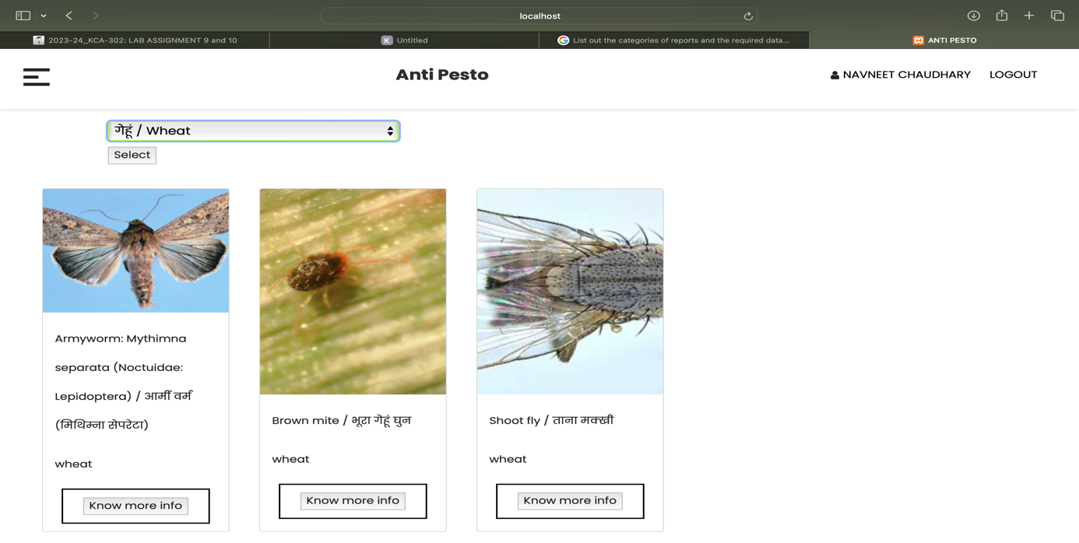

**Show Pests and crops information**

Their select various crops to get result of that pests related to that crops and pests.

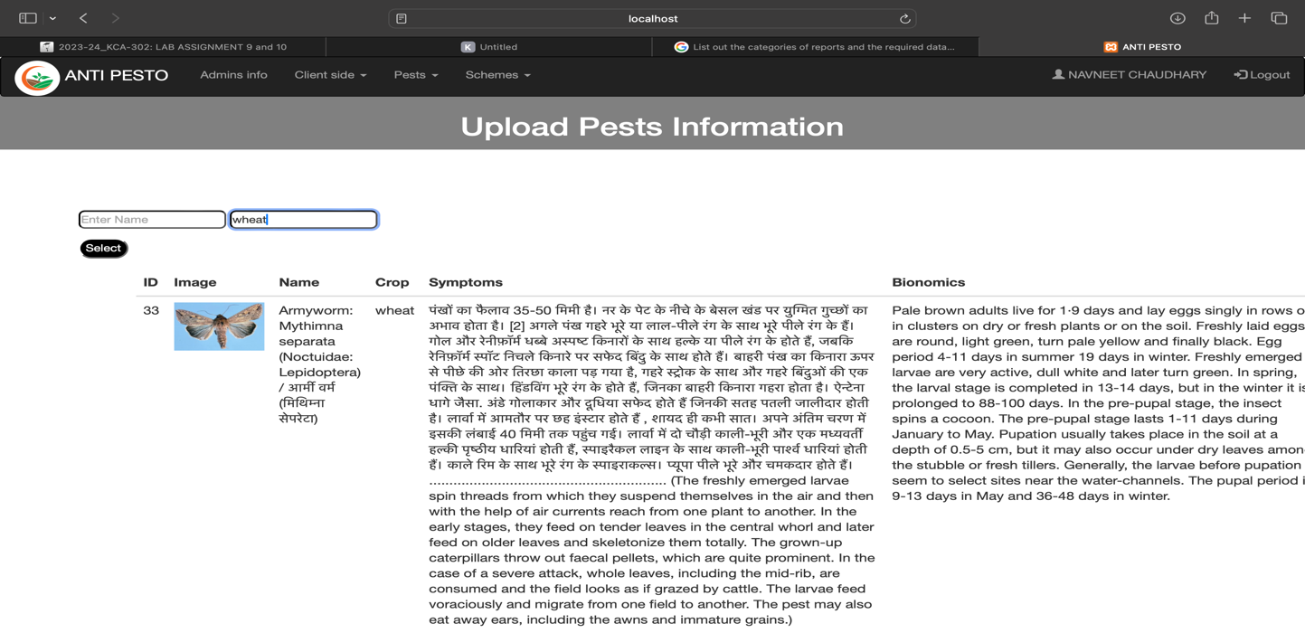

**Upload Pests information**

Put name or crop to get data from there and get needed information.

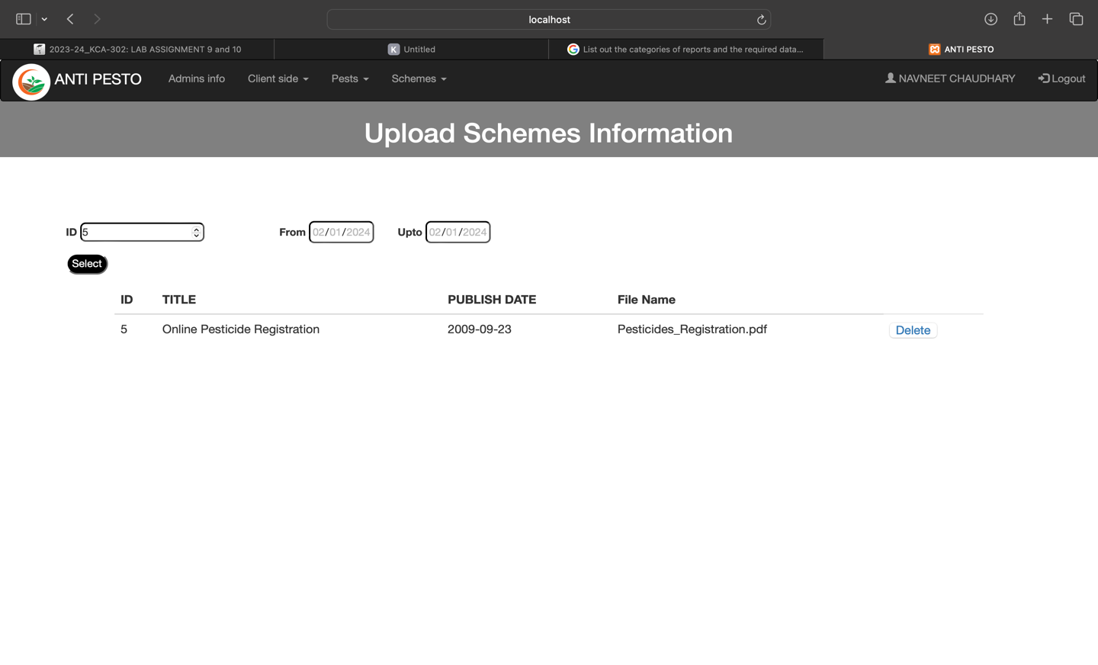

**Upload schemes information**

Put Id or from date or before date to get data from there.